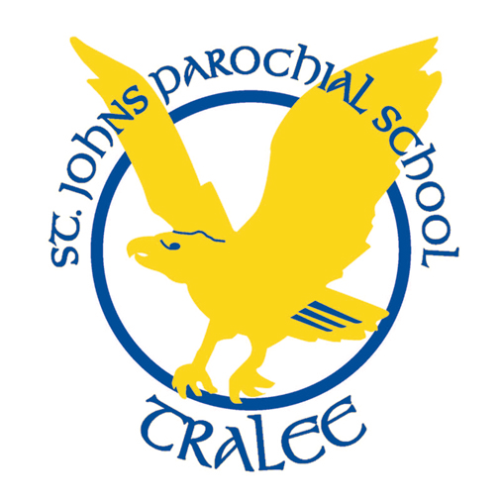St John’s Parochial School, Ashe St, Tralee
Telephone: 066 7128142 E-mail: jschooltralee@gmail.com
Dear Parents/Guardians,
Below is your child’s classroom needs for 2023/2024. All books are supplied and paid for by the school. We do not ask for any contributions towards the running of the school, we try to raise money via different fundraising events.
The money that you have to pay each year is towards your child’s 24 hour, 365 days per year insurance, art materials, photocopying as well as digital licencing. The cost of this is €40 per year and is to be paid to the school before the end of September.
1st and 2nd class:
To be bought for August 30th:
- 2 Pencils
- Eraser - full one rather than one on top of pencil
- Sharpener
- Colouring Pencils or Twistables
- Pencil case
- Apron or old adult's T-shirt, for art, to be left in school for year
- Glue Stick

Please have all MATERIALS and UNIFORM LABELLED!

