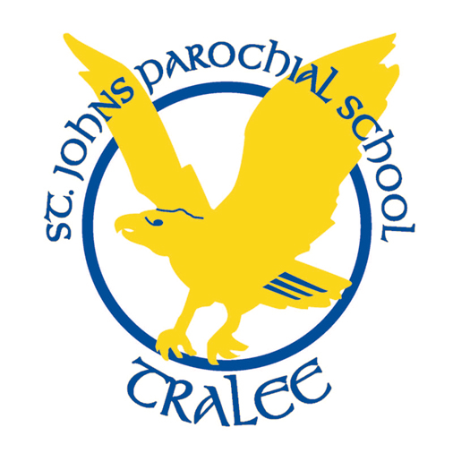St John’s Parochial School, Ashe St, Tralee
Telephone: 066 7128142 E-mail: jschooltralee@gmail.com
Dear Parents/Guardians,
Below is your child’s classroom needs for 2023/2024. All books are supplied and paid for by the school. We do not ask for any contributions towards the running of the school, we try to raise money via different fundraising events.
The money that you have to pay each year is towards your child’s 24 hour, 365 days per year insurance, art materials, photocopying as well as digital licencing. The cost of this is €40 per year and is to be paid to the school before the end of September.
5th and 6th class:

To be bought for August 30th:
Mathematical Set
3 x Blue pens, 3 x Red Pens
Pencils
Ruler, Rubber, Sharpener
Glue Stick
Whiteboard Marker
Colouring markers or pencils.
Please have all MATERIALS and UNIFORM LABELLED!

